**Marketing campaign dataset:**

1. **Loading the data**

I downloaded the dataset from the following link [Customer Personality Analysis (kaggle.com)](https://www.kaggle.com/datasets/imakash3011/customer-personality-analysis) to start my journey with it.

But once I tried to open the dataset I faced my first problem (Excel was having a problem on opening the dataset)

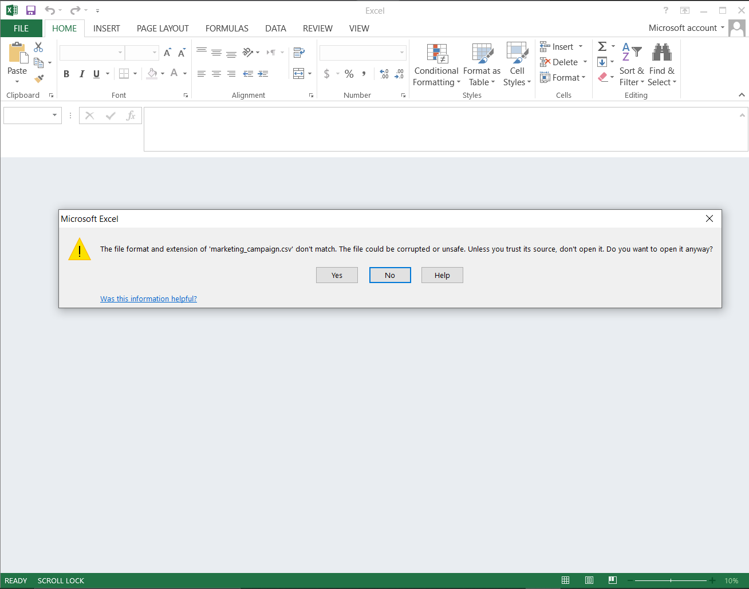

After I saw this message I decided to try to give it a chance and pressed yes because it was supposed to be csv file (that what was mentioned in kaggle), but once I pressed yes this what I had got

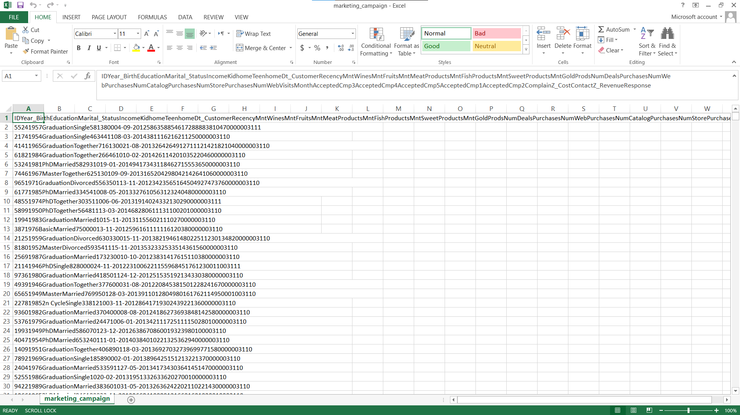

As you can see all the columns just gathered in one column in a very messy way.

To be able to detect where the real problem is I decided to try to open the file with the normal notepad (to be sure that the file is really comma separated file) and that’s what I had found:

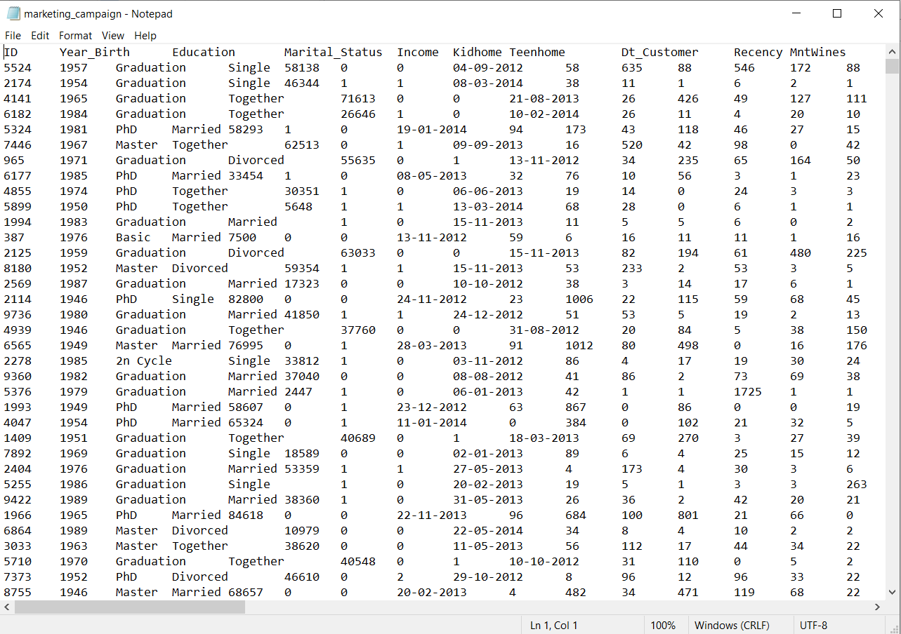

As I expected the file format wasn’t set correctly as the file seems to be tab separated values (TSV) and not comma separated values (CSV)

I saved the file as TSV file and then used a converter to convert it to CSV file (as my version of excel cannot open TSV files directly)

And that’s what I got:

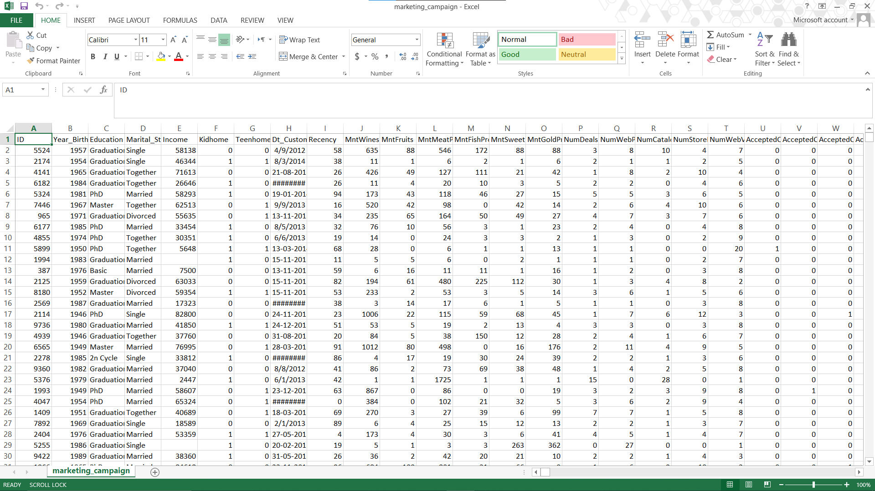

Now it’s organized and I can work with this data on excel as I was wishing

1. **Data cleaning**
2. **Remove the duplicates**

There was no any duplicates in this dataset



1. **Drop unwanted columns**

ID column: as it won’t be helpful in any type of analysis

Other columns can be helpful so I will leave them for now

1. **Check for the nulls**

The only blank cells I found in this data was in the Income column

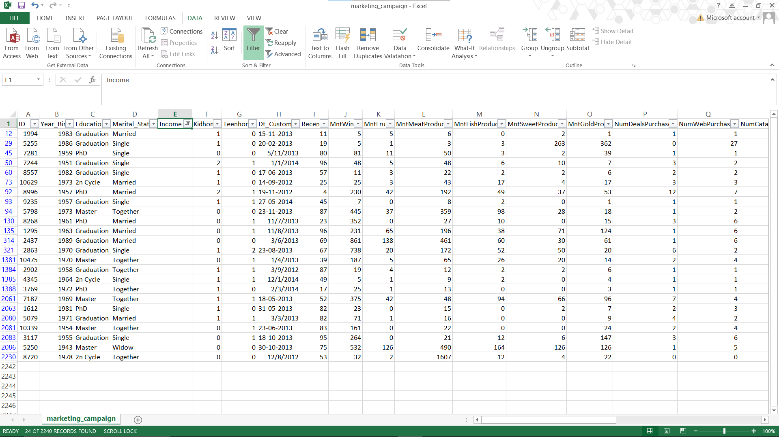

This column is main column for my analysis and that’s why I will drop all the rows with blank income

1. **Standardize categorical columns**

The only columns that should be standardized are DT_Customer and marital status

First the DT_Customer column: I converted the type of the column into text to be able to standardize the values into one format

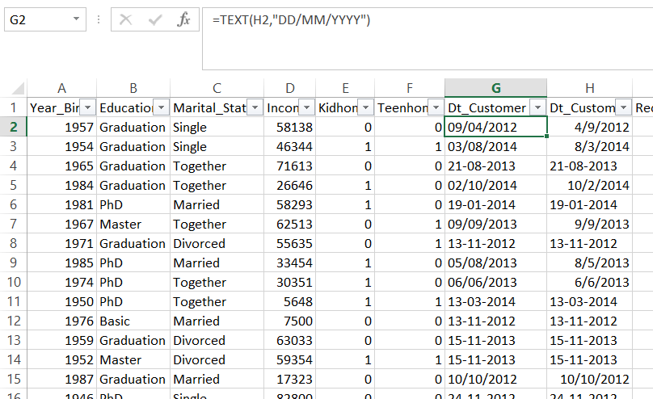

Then I standardized values to one forma which is “DD/MM/YYYY”

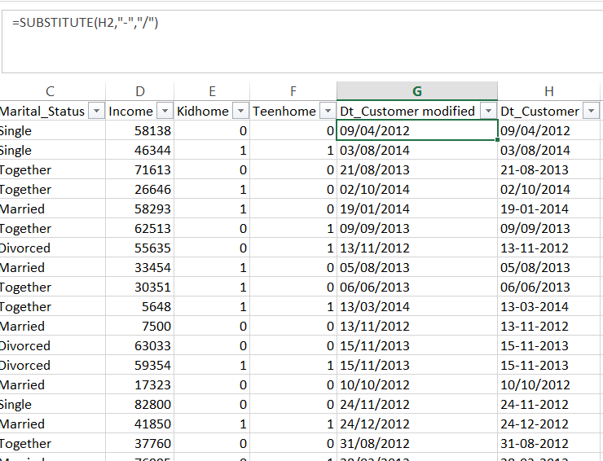

Now the column is much better and I will leave it as a Text data type

Second Marital_Status: I will deal with only four types of marital type (Single, Married, Divorced, Widowed) as they are the main categories

The values of the column we have in our data are:



I am using Excel 2013 and it doesn’t have IFS formula

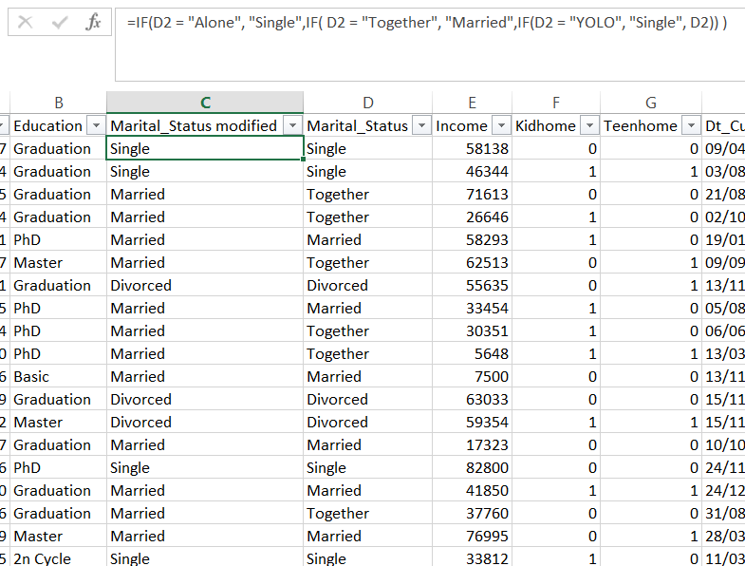

And I will remove the rows with Absurd status as it’s a joke not real value

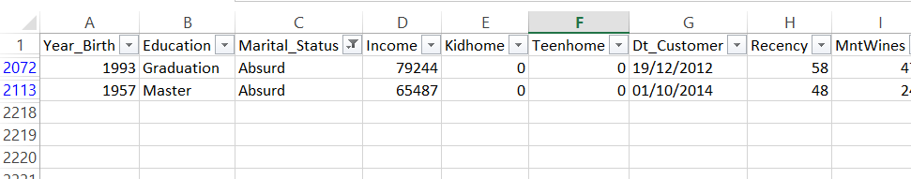

1. **Data types**

Convert all columns that contain numbers only to number data type

1. **Creating Pivot tables**

I created some pivot tables to help me making the final dashboard

**First pivot table**: mainly to see the activity on the web for each education degree

**Second pivot table:** to explore the average number of the different type of purchases based on the marital status

**Third pivot table:** to see the relation between number of kids for the customer and the average number of days since last visit

**Fourth pivot table:** Average income based on marital status for each education degree

**Fifth pivot table:** Showing the amount spent on different things based on the marital type

1. **Making the dashboards**

The dashboard I made shows some interesting information based on the marital status

**First chart:** Based on the fourth pivot table this chart shows the average income of each marital status for each education level

**Second chart:** Based on the fifth pivot table the chart shows total amount spent on each category

**Third chart:** Based on third pivot table it shows the relation between number of kids and how long it take between visits by average

**Fourth chart:** chart to visualize the second pivot table

**The slicer:** to be able to filter based on education level for the last three charts to explore more insights